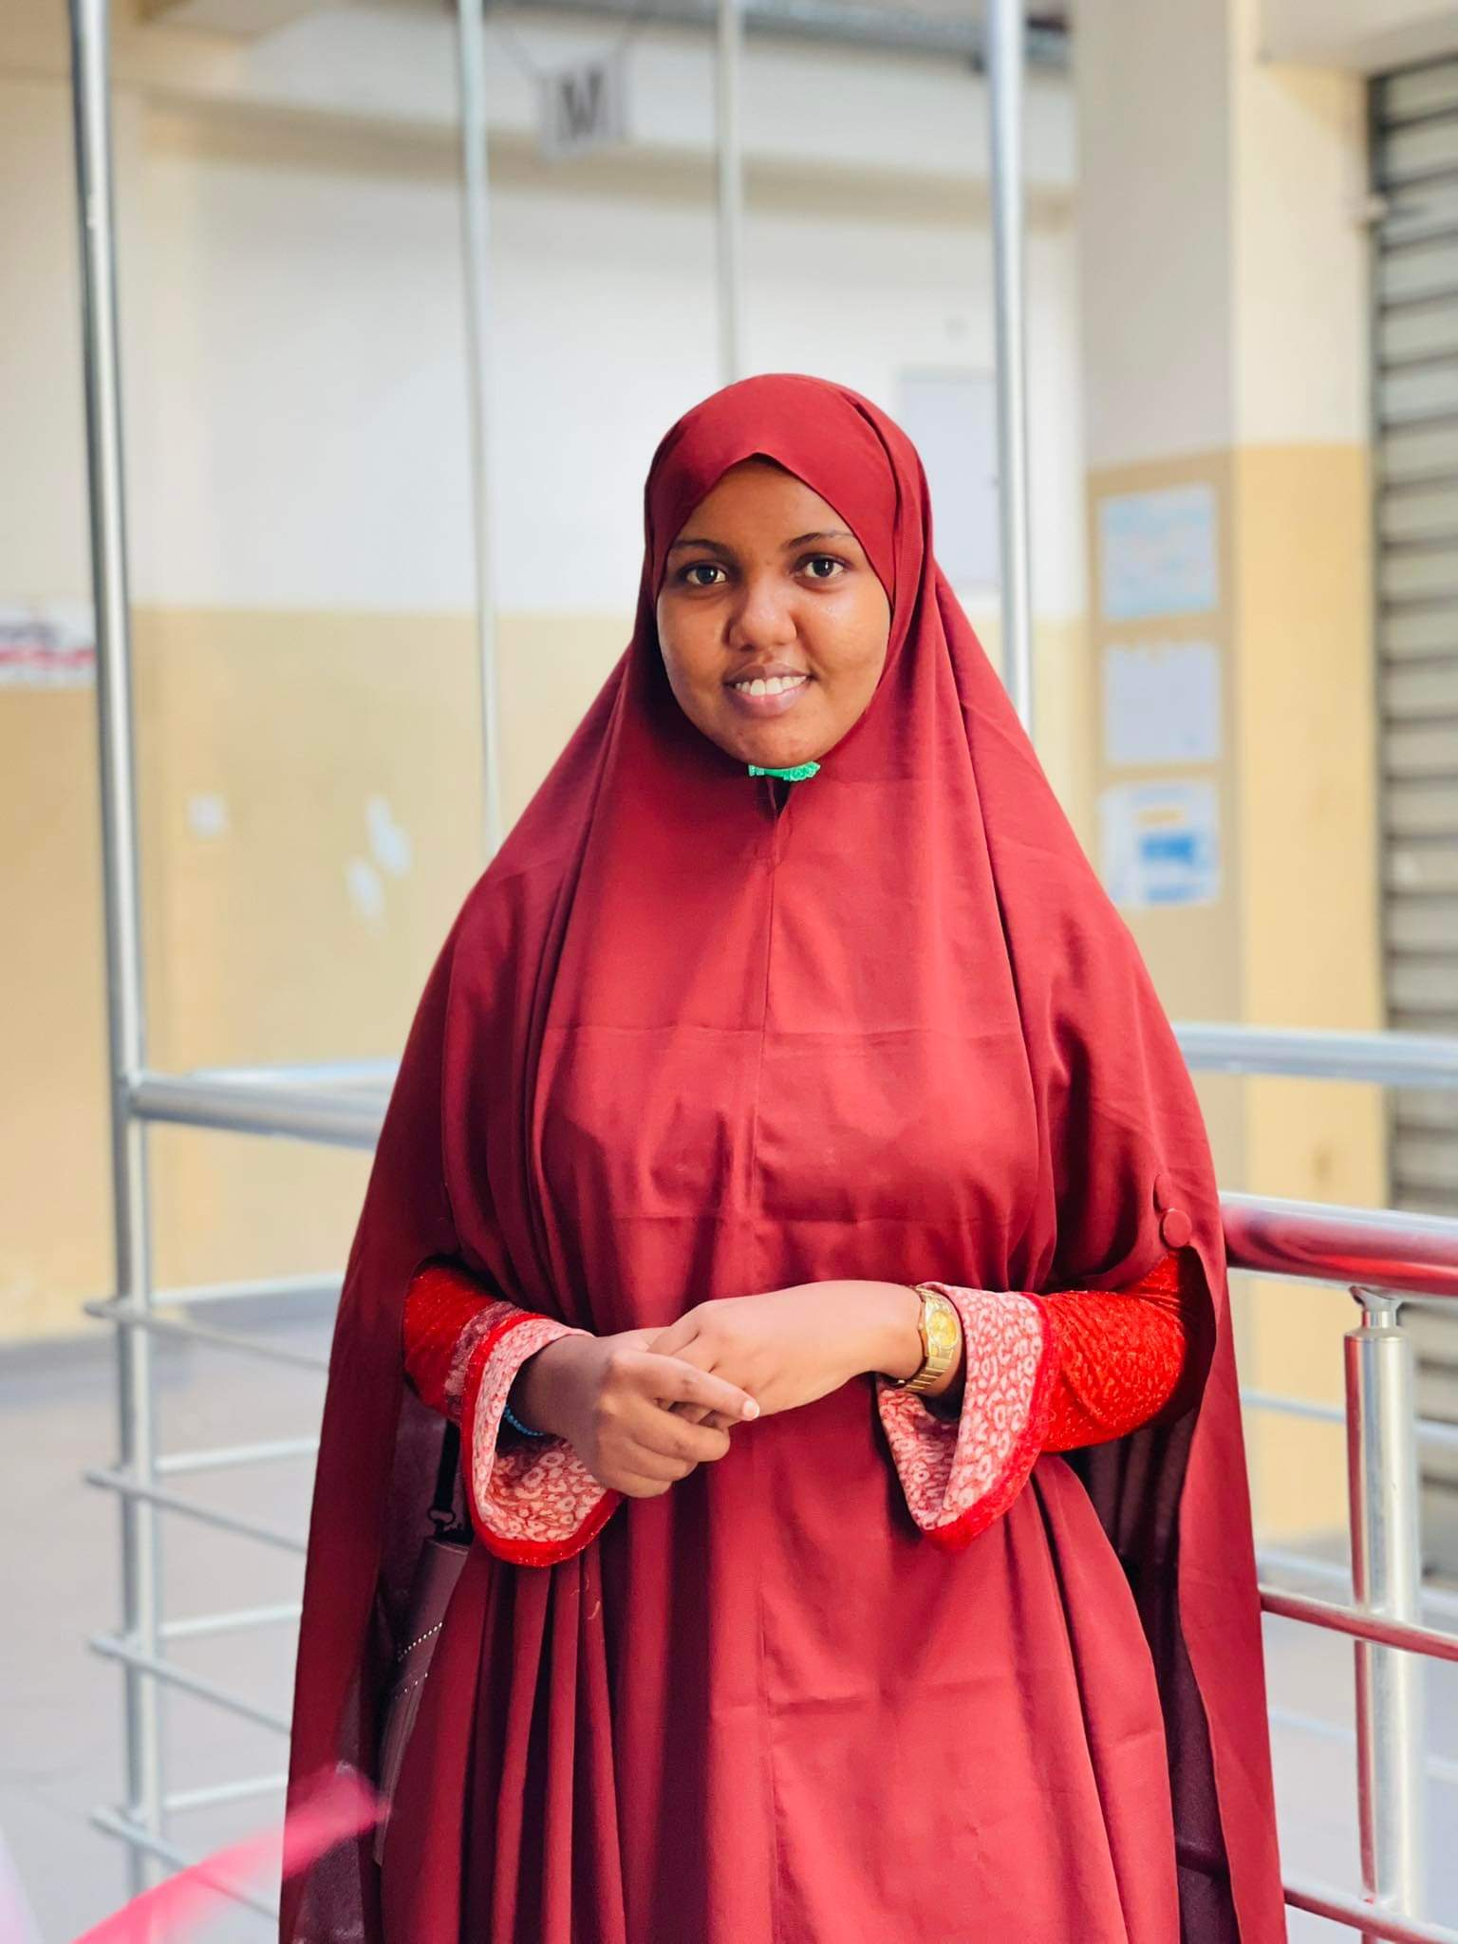

I'm Aisha Hassan, I'm web developer , Graphic Design , Video Editing My journey in the tech world began out of Rise Academy over the time, transformed into a thriving profession. With more than six month of intensive experience in the industry, I have consistently turned imaginative ideas Through these roles with my critical thinking and leadership skills as well as my teamwork spirit. Those are the skills that I have improved, concretized and strengthened.

**About Me**

***LANGUAGES***

***Aisha Hassan Hussein***

**061-7993837**

[**aishahasan164@gmail.com**](mailto:aishahasan164@gmail.com)

**Distract kaaran Mugdishu,Somali**

**EDUCATION**

***SKILLS***

**Kownayan UNIVERSITY**

Bachelor Degree ICT

2018/2022

**MogBits**

Diplom Graphic Design

Feb/2023

**.** Graphic Design

**.** Video Editing

**.** Web Developer

**REFERENCE**

**. Somali**

**. English**

Abdimajiid Abdikadir

Director Samewade academy

Telephone :252 619545300

Gaheyar

Teacher MogBits

Telephone :252 610901529

***HOBBIES***

**.Travelling**

**.Reading**

**.Camera Operator**